**SATIM - An Energy Systems Model for South Africa**

**Authors:** Alison Hughes, Bruno Merven, Bryce McCall, Tara Caetano, Faaiqa Hartley, Fadiel Ahjum, Gregory Ireland, Jesse Burton, Andrew Marquard,

**Abstract:**

South Africa faces many energy challenges and opportunities. Amongst the challenges are constraints to electricity supply and a rising cost of electricity to consumers, high levels of energy poverty, and a heavy reliance on coal in the supply and demand sectors. Energy systems models are useful tools to explore development pathways that address these and other challenges. This paper describes SATIM, the South African TIMES model, in terms of its methodology, structure, and application. SATIM is a full sector model of South Africa that includes a detailed representation of key components of the energy system, such as coal supply to power plants from mines, liquid fuels production using CTL and GTL plants, the representation of intensive energy industries in terms of their process flows and the representation of residential energy consumption for different income levels and electricity access. Due to the technical and process detail in the model it is suited to a wide range of applications and has already been applied to the development of national policy responses to climate change. In addition to providing an overview of important features of SATIM, this paper supports the move towards open and transparent use of SATIM and the development of similar models in other countries.

# Introduction

Energy systems models provide insights into complex energy challenges such as climate mitigation responses, ensuring energy security and maintaining grid stability as renewable energy (RE) integration increases (Li, Bataille, Pye, & Sullivan, 2019; Lopion, Markewitz, Robinius, & Stolten, 2018). Energy systems models that include supply and technology detail as well as demand for energy services are powerful tools capable of delivering valuable insights into optimal energy system configuration and how this might change as new technologies or fuels are introduced, or behaviour and needs change.

Developing countries face many complex challenges related to energy supply and demand. On the demand side challenges include aspects such as low electrification rates, the use of inferior fuels that have harmful health impacts, un-serviced demand and inefficient servicing of demand. On the supply side challenges include the need to increase supply (often rapidly) within constrained budgets to meet economic development, uncertainties around economic growth and how this translates to individual welfare, carbon intensive energy supply systems and a rapidly evolving energy technology landscape. In addition to these challenges the analysis of both supply and demand is hampered by the lack of data, and policy uncertainty.

South Africa (SA), like other developing countries, faces many challenges on the road to achieving its energy system aspirations. SA is a high GHG emitter and heavily coal reliant. RE is being introduced into the electricity supply system, but only comprised 3.7GW out of a total installed capacity of over 50GW in 2018. A transition away from coal is likely, however, concerns around coal sector job losses and their associated welfare impacts may delay implementation. CTL and GTL plants supply 16 percent of liquid fuels.

In addition to the supply side challenges, South Africa has high inequality and poverty. Household energy poverty is around 50% (StatsSA, 2019). Energy services and modern fuels are often unaffordable to low income households, which rely on multiple fuels, including collected fuelwood and coal to supply their energy needs (DOE, 2013). Energy sector challenges include the need to increase electrification from its current level of around 85%, a need to reduce energy poverty and the use of solid fuels by households, realising opportunities to improve energy efficiency in all sectors, realising the potential for demand shifting, and transitioning away from coal.

Systems models are essential tools for understanding the challenges and opportunities surrounding energy planning. Energy systems models contribute towards understanding the energy system in economic, social and environmental terms, and the complex synergies and trade-offs between each of these when providing for future energy needs. Energy systems models can take into consideration various constraints or targets which include energy access targets, energy transition goals, distributed generation as an alternative where use is low and demand is sparse, nexus challenges for competing resources and nexus trade-offs.

Many reviews of energy systems models are available, demonstrating their relevance and application over different spatial and temporal scales in developed and developing countries (see Hiremath, Shikha, & Ravindranath, 2007; Jebaraj & Iniyan, 2006; Laha & Chakraborty, 2017; Lopion et al., 2018; Neshat, Amin-Naseri, & Danesh, 2014). They highlight the range of methodologies currently employed to analyse energy systems challenges. Energy optimisation models, developed in response to the 70’s oil crisis are “how to” tools and are critical for evaluating decisions that have long term implications for the energy system under analysis (De Carolis, Hunter, & Sreepathi, 2012; Hiremath et al., 2007). Optimisation models, with technology rich representations of demand and supply, have been applied to a wide range of policy questions in many countries.

In South Africa several modelling approaches have been used to answer key questions related to energy provisioning. For example, PLEXOS has been used in the development of integrated Resource Plans (DOE, 2018) and OSeMOSYS has been used to develop the Integrated Energy Plan. The MARKAL model has been applied to the analysis of climate response, for example in the development of the Long Term Mitigation Scenarios (LTMS). LEAP, a simulation model, has been applied to the development of the National Energy Efficiency Strategy. In addition computable general equilibrium models (CGE) have been used to address energy related questions, for example E-SAGE and UPGEM have been applied to explore the impacts of carbon taxes (Alton, 2014; Blignaut, 2016), and TERM-SA has been used to explore the economic impacts of transitioning to a low carbon energy supply mix (Bohlmann, 2019).

Amongst the models developed to analyse the South African energy system and its interaction with the economy and environment is the South African Times Model – SATIM. SATIM is a full sector, national energy system, least cost optimisation model that can be applied to the planning problem of meeting projected future energy demand given assumptions such as the retirement schedule of existing infrastructure, future fuel costs, future technology costs, learning rates, and efficiency improvements, as well as any constraints such as the availability of resources. The entire energy service needs of the economy are represented in SATIM along with technologies that supply energy and energy services. In this way demand within the model is endogenously shaped by efficiency, fuel and technology costs, the formation of the economy and economic interactions, population growth and income growth, amongst others.

SATIM is unique in its representation of the South African energy system. It includes a detailed representation of all economic sectors. Each sector is adapted to best represent energy demand or supply within the sector. For example, the residential sector captures the inequality in energy access, use of multiple fuels within households to supply the same energy service, fuel subsidies and technology efficiency. The supply of liquid fuels includes a representation of the GTL and CTL plants as well as the large and complex coal supply networks into power plants.

SATIM has been applied to developing an alternative integrated resource plan for South Africa (Mccall et al., 2019), exploration of coal transitions (Burton, Caetano, & Mccall, 2018), analysis of uncertainty in coal prices and climate commitments (Merven, Durbach, & McCall, 2016), and the implications of water constraints for energy planning in South Africa (World Bank Group, 2017). SATIM has also been linked to a CGE model to explore, for example, the macro and socio-economic benefits of increasing RE in the power sector (Merven et al, 2018) and mitigation responses that align with development objectives (Altieri et al., 2016).

There is a growing emphasis on transparency, accessibility and replicability in energy models. In order to improve the transparency to SATIM, which has already been used for policy and policy critique, this paper sets out to provide a description of SATIM, in terms of its design (structure), application, and the strengths and limitations of the model. In doing so, it also provides an example of the use of the TIMES platform to service the energy planning needs of a developing country, and hopefully contributes towards the further development and use of energy systems models in developing countries.

The paper proceeds as follows, section two provides an overview of the salient features of the South African energy system. This is followed by an overview of TIMES and the structure of SATIM in section three. Section four provides an overview of the sectors in terms of the model structure and derivation of energy service demands. Section five presents a discussion of model applications and the strengths and limitations/weaknesses of SATIM.

# Overview of South Africa energy system

Figure 1 provides a SANKEY diagram of the energy system in South Africa. South Africa consumes around 93 EJ of primary energy (National Planning Commission (NPC), 2018). Most of the energy comes from coal, supplied domestically. Coal, which accounts for over 85% of domestic primary energy production is used primarily in electricity generation (70%) and in liquid fuels production (21%) (National Planning Commission (NPC), 2018). Imports are primarily oil and petroleum products, although the bulk of petroleum products are manufactured locally from imported crude oil. Exports of energy are predominantly coal, around 75 Mt/year.

In 2016, coal accounted for 74% of total electricity generation capacity with the balance comprising of hydro and pumped storage, peaking plants such as Open Cycle Gas Turbines (OCGTs), nuclear and renewables. Total capacity in 2016 was 49.8GW (Wright et al. 2017). Around 92% of electricity generation is from coal (DOE, 2016). The aging coal fleet means that expansion of generation capacity is needed to replace both retiring capacity as well as to meet anticipated demand growth. The new-build must also be less carbon intensive to meet South Africa's international climate change commitments as the electricity sector accounts for a significant proportion of national emissions. There is significant potential for a transition towards renewables. South Africa possesses some of the best solar and wind resources in the world, with vast areas of the country being suitable for generating electricity using renewable energy (Hagemann, 2008; Fluri, 2009; WASA, 2015; CSIR 2016).

On the demand side, transport is the highest energy consumer. Liquid fuels used for transport are around 40% of Total Fuel Consumption (TFC). Petrol and diesel consumption for road vehicles are the primary fuels used in the Transport sector accounting for approximately 80% of the sector’s total energy consumption (ERC, 2017). Industry has the second highest energy demand at around 44% of TFC, using around 8% of coal and 62 % of electricity. The residential sector, and commercial sector use around 15% of TFC. Commercial sector energy consumption is mainly electricity, which comprises almost 90% of total energy use. In the commercial sector, coal is the second largest source of energy, followed by LPG and paraffin. Very small amounts of diesel, natural gas and HFO are used (<1 PJ). Household fuel use is diverse and includes the use of both coal and woodfuel, primarily in low income rural or peri-urban households.

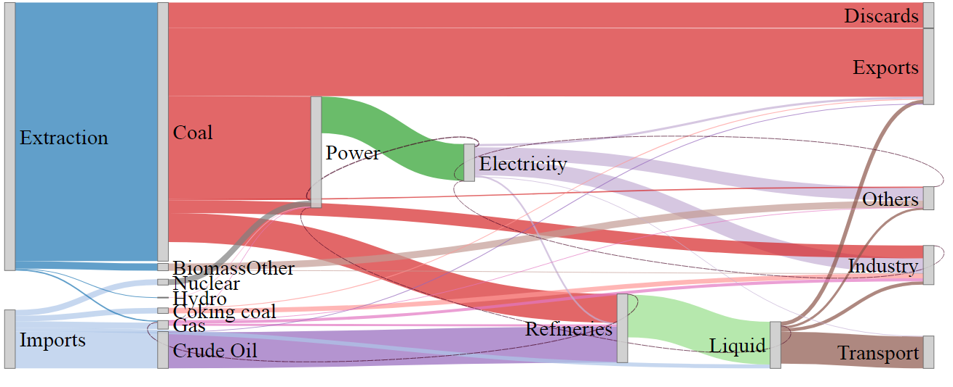

Figure 1 The South African Energy System in 2015

# The South African TIMES model

## TIMES

The Integrated MARKAL-EFOM system (TIMES) was developed by the Energy Technology Systems Analysis programme (ETSAP) a technology collaboration programme of the International Energy Agency (IEA). TIMES is a partial equilibrium, techno-economic, optimisation model generator. The objective in TIMES is to maximise welfare by minimising total discounted system cost. In TIMES, the user has the flexibility to structure the energy system components, which include technologies, commodities, resources, trade and emissions, to suit the energy system under analysis. TIMES allows the user to choose a representative number of time periods in the year to characterise and account for the temporal nature of demand. TIMES also allows the spatial representation of demand, supply and trade between regions. Constraints can be applied to force the system to behave in certain ways, allowing a deviation from true least cost solutions.

## Overview of sectoral and temporal representation of demand and supply in SATIM

SATIM is a single region, multi-sector, multi time period, bottom up (end use) TIMES model. It captures the full economy and it’s energy related emissions (NOX, SOX, CO2, CH4, N2O, CH4, CO, NMVOC’s, PM10), allowing the modelling of carbon taxes and carbon budgets in addition to energy supply, demand, resource utilisation, imports and exports.

Within SATIM there are two supply sectors (electricity and liquid fuels) and five demand sectors (industry, agriculture, residential, commercial, and transport). Each sector is further disaggregated into subsectors as appropriate. Including a detailed representation of both the supply and demand sectors in SATIM explicitly captures the impact of structural changes in the economy (i.e. different sectors growing at different rates), process changes, fuel and mode switching, and technology improvements and efficiency gains.

Each demand sector within SATIM is governed by a number of parameters and general assumptions relating to (a) the structure of the sector and its energy service needs; (b) the base year demand for energy by fuel type; (c) technical and cost parameters of the technologies available to satisfy the demand for energy services in the base year and over the model horizon and; (d) the demand for energy services over the planning horizon.

Base year demand and projected demand is exogenously specified in terms of the demand for useful energy in each sector. This allows fuel substitution, as well as technology improvements, which influence the efficiency at which energy services are met, to endogenously determine the final energy demand in the sector.

The level of detail in which each sector is modelled in terms of technology and sector disaggregation reflects the relative contribution of the sector to total consumption as well as the level of funding that has been available for developing that sector in the model. Thus the Transport sector, which is a large energy user and has been a focus of model development for several years, is quite detailed compared to the Agricultural sector, which accounts for a relatively small percentage of TFC and emissions and is quite simplistically represented in SATIM. The disaggregation of the supply and demand sectors is discussed further in Section 4.

Resources include local extraction, imports and exports and renewable energy (RE). Coal mines supplying ESKOM power stations are represented individually. This allows coal transport and coal costs to each power station to be explicitly included in each scenario. Resource extraction also includes oil and gas from local fields, as well as future potential for coal, oil, and gas extraction.

Figure 2 depicts the SATIM model components while Table 1 summarises the economic demand sector representation in terms of the sub-sector and end use disaggregation and sector drivers.

The model planning horizon spans from 2012 (the base year) to 2050. The base year replicates South Africa’s energy system in 2012 and 2017. A detailed description of the 2012 year energy balance calibration can be found in (Hartley, 2018), with the 2017 documentation still in progress.

SATIM uses timeslices to model typical end use load profiles and RE resource availability for winter and summer. The load profiles include a morning and evening peak and night time period with lower average demand. The winter evening peak timeslice is used to determine the system peak demand up to which the system must build firm dispatchable capacity with a 15% reserve margin.

Due to the increased computational time needed with increased timeslice resolution, SATIM has been developed to easily accommodate different timeslice resolutions in order to accommodate a range of research questions. Temporal changes in daily and seasonal demand in the lowest resolution version of SATIM are represented by two seasons and one day type. Winter days consist of 5 timeslices and summer three timeslices. The highest resolution version currently allows for 72 timeslices, representing 2 winter days and 2 summer days. The temporal resolution is applied to end use demand and RE, apart from transport where demand is defined annually.



Figure 2: Schematic Summary of the South African Times Model (SATIM)

Table 1: Summary of Economic Sector Representation in SATIM and their Main Drivers

|  |  |  |  |
| --- | --- | --- | --- |
| **Sector** | **Subsector Disaggregation** | **End use Disaggregation** | **UE demand Driver** |
| Agriculture | None | Irrigation, heating, processing, traction, other. | Sectoral GDP |
| Residential | High, medium and low-income electrified households | Cooking, water heating, space heating, refrigeration, lighting, other electric | Population, Household-income, electriﬁcation rate |
| Medium and low-income non-electriﬁed | Cooking, water heating, space heating, lighting |
| Commercial | None | Cooling, space heating, cooking, lighting, refrigeration, water heating, public lights, public water | Sectoral GDP, building stock |
| Industrial | Iron and Steel, Ferroalloys, Non-metallic minerals and pulp and paper | Tonnes produced by Industrial processes | Sectoral GDP |
| mining, chemicals, food beverages and tobacco, precious and non-feroorus metals and gereral manufacturing | Boiler and process heating, cooling, HVAC, lighting, fans, pumping, compressed air, electrochemical and other electrical services |
| Transport | Air, Freight and Pipeline | Freight tonne km by rail and road (1 light vehicle class, 9 heavy vehicle classes) | Transport GDP, Population and household category and income |
| Private passenger | Passenger kilometre travel by Cars, SUV, motorbikes | Household income |
| Public passenger | Passenger kilometre travel by Bus, train, minibus, BRT | Household income |

## Drivers of energy demand within SATIM

Primary drivers of demand are population and GDP. Population growth directly impacts the demand for energy in the residential and transport sectors and indirectly in all other demand sectors. Population growth follows the central (median) case from the World Population Prospects 2019 (DESA, 2019), increasing to 75.5 million in 2050.

Whilst population forecasts are generally kept constant in all scenarios, GDP growth can change in response to prices or policy targets etc. GDP growth in each economic sector, along with anticipated household income levels, is drawn from a CGE model. While CGE models are not forecasting tools, they do generate economically consistent paths of economic growth, including sector growth, employment and household welfare, for a given set of assumptions.

Useful Energy (UE) demand (the demand for energy services) is exogenously specified. UE demand projections to 2050 are calculated based on the growth of primary drivers and are therefore based on assumptions around how anticipated population and GDP growth will translate into a growth in commercial floor area, household income levels, industrial sector production, demand for transport passenger km and freight tonne km in different transport modes, and agricultural production.

# SATIM supply and demand sector descriptions

## Representation of electricity and liquid fuels supply in SATIM

The supply sector includes the extraction of primary resources, production of electricity and liquid fuels, as well as imports of electricity, oil and other liquid fuels products, and export of coal, electricity and liquid fuels products. Export of electricity is exogenously and fixed at the base year value. Coal exports are flexible but subject to a constraint on growth (decay or increase) rate of 5% per year. Overproduction of liquid fuels is exported. Import of electricity is constrained to regional projects listed in the South African Department of Energy Integrated Resource Plans, it is largely hydro from Inga.

### Electricity

Within SATIM, the power sector is split into Generation, Transmission and Distribution, shown graphically in Figure 3. The Generation component is modelled in the most detail. Operating power plants are represented individually and the power sector in SATIM therefore includes the expected decommissioning schedule of coal fired power plants, all planned new builds, planned retrofits as well as plant technology characteristics (efficiency, capacity factors etc). The expected decommissioning schedule of the existing coal fleet, air quality plant retrofit schedules for fabric filter plants (FFP) and low NOx burners (LNB) are assumed to follow Table 2, although it is possible to run scenario with endogenous retirement of existing and new coal power plants. Flue gas desulfurization (FGD) retrofits are not accounted for. Medupi and Kusile are decommissioned after 2050 which falls outside of the planning window.

New build options include nuclear, wind, solar, coal and gas, hydro, pumped storage and battery technologies. In SATIM solar PV and wind are conservatively assumed to be unable to contribute to peak demand (0% ‘capacity credit’). Dispatchable generation and storage is built to meet a 15% reserve margin firm capacity requirement. Unscheduled outages are also accommodated for through this reserve margin.

Although there may be practical build rate limitations for example because of transmission expansion, port limitations, local skills capacity, manufacturing etc., no upper limits on annual new build for wind and solar are included in the SATIM reference case, allowing the system to choose the least-cost optimal energy mix without artificial constraints.

Since South Africa is modelled as a single node in SATIM, transmission and distribution losses are applied as aggregate losses in the model. Under this configuration, shifting generation from current locations to more dispersed locations does not impact results for instance as a result of developing a significant amount of renewable energy capacity.

Transmission capacity is modelled as a single technology linking centralised/high voltage electricity (ELCC) to medium voltage (MV) electricity lines (ELC). Transmission of electricity between ELCC and the MV distribution network incurs a loss of 4%. MV electricity is distributed to each sector in a way that captures the different levels of losses that are incurred distributing electricity to the sector. For example, the distribution of electricity to residential households is assumed to incur a loss of 19.7% whereas the distribution of electricity to the industrial sectors (excluding mining) incurs a smaller average loss of 6.%. Note that for purposes of simplicity, the supply technologies and sector distribution legs are aggregated in Figure 3.

U235

Coal

ELCC

ELC

Nuclear Plant

Coal Plant

OCGT Plant

Hydro Plant

Solar/Wind Plant

Diesel

RE

GENERATION

Transmissiont

Pumped Storage

CoGen

Distribution to Residentialt

Distribution to Industryt

Distribution to Commercialt

Residential Electricity

Heat to Industry

Industrial Electricity

Commercial Electricity

TRANSMISSION

DISTRIBUTION

Figure 3: Simplified Schematic of the South African Power Sector in SATIM

Technologies that lie within the transmission and distribution network are pumped storage, cogeneration and distributed renewables. Losses in the transmission of electricity to and from these technologies is accounted for as follows:

* Pumped storage stations lie between generation and distribution. They use electricity distributed through the transmission grid and feed electricity back into the transmission grid, these plants therefore incur transmission losses twice.
* Cogeneration occurs after transmission and electricity is fed into the distribution grid to meet industrial electricity demand. The heat generated is used to meet industrial heat demand.
* Distributed energy technologies built within a sector such as embedded solar or storage are not subjected to distribution losses and are currently not able to feed electricity into the central network to reach the other sectors.

Table 2: Eskom plant decommissioning and air quality retrofitting schedules[1] (Sources: IRP 2016, Eskom, DEA)

|  |  |  |  |  |  |  |  |  |  |  |  |  |  |  |  |  |  |  |  |  |  |  |  |  |  |  |  |  |  |  |  |  |  |  |  |
| --- | --- | --- | --- | --- | --- | --- | --- | --- | --- | --- | --- | --- | --- | --- | --- | --- | --- | --- | --- | --- | --- | --- | --- | --- | --- | --- | --- | --- | --- | --- | --- | --- | --- | --- | --- |
|  | 2016 | 2017 | 2018 | 2019 | 2020 | 2021 | 2022 | 2023 | 2024 | 2025 | 2026 | 2027 | 2028 | 2029 | 2030 | 2031 | 2032 | 2033 | 2034 | 2035 | 2036 | 2037 | 2038 | 2039 | 2040 | 2041 | 2042 | 2043 | 2044 | 2045 | 2046 | 2047 | 2048 | 2049 | 2050 |
| Majuba |  |  |  |  |  |  |  |  |  |  |  |  |  |  |  |  |  |  |  |  |  |  |  |  |  |  |  |  |  |  |  |  |  |  |  |
| Kendal |  |  |  |  |  |  |  |  |  |  |  |  |  |  |  |  |  |  |  |  |  |  |  |  |  |  |  |  |  |  |  |  |  |  |  |
| Matimba |  |  |  |  |  |  |  |  |  |  |  |  |  |  |  |  |  |  |  |  |  |  |  |  |  |  |  |  |  |  |  |  |  |  |  |
| Lethabo |  |  |  |  |  |  |  |  |  |  |  |  |  |  |  |  |  |  |  |  |  |  |  |  |  |  |  |  |  |  |  |  |  |  |  |
| Tutuka |  |  |  |  |  |  |  |  |  |  |  |  |  |  |  |  |  |  |  |  |  |  |  |  |  |  |  |  |  |  |  |  |  |  |  |
| Duvha |  |  |  |  |  |  |  |  |  |  |  |  |  |  |  |  |  |  |  |  |  |  |  |  |  |  |  |  |  |  |  |  |  |  |  |
| Matla |  |  |  |  |  |  |  |  |  |  |  |  |  |  |  |  |  |  |  |  |  |  |  |  |  |  |  |  |  |  |  |  |  |  |  |
| Kriel |  |  |  |  |  |  |  |  |  |  |  |  |  |  |  |  |  |  |  |  |  |  |  |  |  |  |  |  |  |  |  |  |  |  |  |
| Arnot |  |  |  |  |  |  |  |  |  |  |  |  |  |  |  |  |  |  |  |  |  |  |  |  |  |  |  |  |  |  |  |  |  |  |  |
| Hendrina |  |  |  |  |  |  |  |  |  |  |  |  |  |  |  |  |  |  |  |  |  |  |  |  |  |  |  |  |  |  |  |  |  |  |  |
| Camden |  |  |  |  |  |  |  |  |  |  |  |  |  |  |  |  |  |  |  |  |  |  |  |  |  |  |  |  |  |  |  |  |  |  |  |
| Grootvlei |  |  |  |  |  |  |  |  |  |  |  |  |  |  |  |  |  |  |  |  |  |  |  |  |  |  |  |  |  |  |  |  |  |  |  |
| Komati |  |  |  |  |  |  |  |  |  |  |  |  |  |  |  |  |  |  |  |  |  |  |  |  |  |  |  |  |  |  |  |  |  |  |  |

|  |  |  |
| --- | --- | --- |
|  | Emission abatement retrofit | |
|  | 50 year life decommissioning |

### Liquid Fuels

Commodities produced by the South African liquid fuels sector at present are petrol (gasoline), diesel, kerosene (jet fuel / illuminating paraffin), aviation gasoline, liquid petroleum gas (LPG), heavy fuel oil (HFO) and methane-rich gas (produced by the synthetic fuels industry only). In SATIM Liquid fuels can be supplied from three sources namely- crude oil refineries, synthetic fuels manufactured from coal and gas, and biofuels (ethanol and biodiesel).

South Africa has 3 conventional crude oil refineries situated at the coast, and one that is situated inland. The coastal refineries are grouped together in SATIM, as they have similar product distillate and operating inputs. The inland crude refinery has a more diesel- and kerosene- heavy product distillate, and the two synthetic refineries have a gasoline-heavy distillate, thus they are characterized separately in SATIM. Product slates are modelled by applying an assumed upper bound output commodity share for each commodity. In existing the product remains the same over the planning period, new refineries are modelled in a way that can accommodate a varying product slate.

Refineries can have various commodity inputs, which can include crude oil, coal, gas, methane rich refinery gas and steam. In SATIM Steam is modelled as an ancillary input service to CTL plants. Steam is supplied by boiler technologies using energy as an input. The modelling of steam as an ancillary input service allows the model to optimise the most cost effective fuel (e.g. coal, gas) and technology (e.g. existing vs new and more efficient boiler vs CHP) to provide the steam needed for process heat, as well as for feedstock in CTL plants. This latter use is much greater than process heat requirements. Steam is also used in crude refineries and GTL plants but further data is required for the characterization and therefore this consumption is not currently reflected in SATIM. The steam consumption of crude and GTL refineries is however significantly lower and the absence of this detail is assumed to not have a very significant impact on the overall results.

The enhanced fuels standards currently contemplated by the Department of Energy will require considerable upgrading of existing liquid fuels infrastructure. In the reference case it is assumed that new fuels standards will be rolled out by 2025 due to the delays in implementation, by which time existing refineries will either have to make significant investments, or shut down. The estimated capital investment for refineries to migrate from CF1 to fuel quality compatible with Euro 4 and Euro 5 emissions standards is $3.2 billion to $3.7 billion (2009 dollars).

Biofuels are modelled in conjunction with the transport system demand for fuel either by blending them into existing liquid fuels in concentrations below 10%, or via investment in biofuels-specific vehicles.

Refineries new and exiting

Oil

Electricity

Gas

Coal

CTL

new and exiting

GTL

new and exiting

Electricity

Electricity

Oil

Gas

Steam

HFO (Ag, Com, Ind, Tra)

Gasoline (Ag, Com, Ind, Tra)

Diesel (Ag, Com, Ind, Tra, Power)

Kerosene (Ag, Com, Res, Tra)

LPG (Ag, Com, Ind, Res)

AvGas (Tra)

Figure 4: Simplified Schematic of the South African Refineries Sector in SATIM

## Representation of Energy Demand in SATIM

### Residential

Households are the basis of demand in the residential sector. Household energy use is very diverse, and there are several distinguishing features that have been found to be important in determining the quantity of energy used by households, their fuel choice and demand profiles. Amongst the important influencers are income, access to electricity, access to water and housing type. There is a distinct increase in both overall fuel consumption, as well as appliance ownership and the use of modern fuels as income increases.

To account for the influence of income and electrification on household consumption, SATIM includes three categories of households distinguished by their level of income. Each household grouping is distinct in its demand for energy services, and the technology penetration used to supply energy services.

Drivers of demand in the Residential Sector are population and household income growth. Projections of household growth in each household category in the model rely on assumptions around the evolution of population growth, household size, household income levels, and the success of the electrification programme. An exogenous projection of the electrification rate is required to derive a household split between the electrified and unelectrified households in the two lower income groups. This is based on historical trends and future government/Eskom targets, and is shown in Table 3 until 2050.

Table 3: Assumed Future South African Electrification Rates by Income Group

|  |  |  |  |  |  |
| --- | --- | --- | --- | --- | --- |
| **Income Group** | **2010** | **2020** | **2030** | **2040** | **2050** |
| Low Income | 71% | 80% | 85% | 90% | 95% |
| Middle Income | 83% | 90% | 95% | 95% | 100% |
| Overall Electrification | 81% | 90% | 95% | 97% | 100% |

Changes in demand occur as households shift groups, or through exogenous responses to sector market shifts. Useful energy demand remains the same in the lower two income groups where median income is held constant, but in the highest income group the median income can change and the demand for useful energy services is linked to income using elasticities. By disaggregating households according to their income and electrification status, the model can incorporate and react to policy interventions which target certain households (i.e. an increase in residential electricity tariff for high energy consumers) as well as mitigation actions relevant to a specific household groups (i.e. a solar hot water heating programme on low income households).

The splitting of households into income bands is largely governed by appliance ownership, (Beute, 2010), (Dekenah, 2010) (Gertler, Shelef, Wolfram, & Fuchs, 2012). National surveys are the primary source of data for the split (IES and Census or community survey). The base year calibration, in terms of fuel use and energy service demands, relies on a combination of large national surveys that match income group to fuel use for lighting, heating, and cooking and capture appliance ownership (SWh, TV) etc, and bottom up surveys, which can be large or small scale and capture user behaviours or tie quantities of energy to energy services that can be matched to the income groups. The demand for energy services in each group is therefore an indicative estimate and the representation of the sector in further detail is limited by data availability.

The base year calibration of UE attributed to each household group is calculated as follows:

**Uijn = EIijn X Hin**

Where **Uijn** is the useful energy demand for income group i using energy service j in year n (GJ), **EIijn** is the energy Intensity for income group i using energy service j in year n (GJ/per household/year) and **Hin** is the number of households i in year n (households)

### Transport

The transport sector in SATIM includes energy used for passenger and freight transport by road, rail. It also includes energy used in pipeline transfers and aviation. Energy demand for passenger and freight transport is driven primarily by two factors, a) vehicle-kilometers travelled and b) the efficiency of travel. The vehicle‐ kilometers travelled are driven by the needs of society and the economy to move people and goods around. Conversion efficiency differs with vehicle type, fuel type and the age of the vehicle parc and to some degree the patterns of utilisation of different vehicle types. The energy service demand in SATIM is defined in terms of passenger kilometres and tonne kilometres.

A calibrated vehicle parc model[2] is used to estimate demand for passenger kilometres (pkm). Aspects of transport included in the parc model are the size of the existing vehicle fleet, annual vehicle sales, annual vehicle scrapping, distance travelled per vehicle, fuel sales and vehicle fuel efficiency. Outputs of the vehicle parc model are total kilometres travelled, the average age of vehicles in the vehicle fleet and the average efficiency of the vehicle fleet. These components allow efficiency or intensity of transport to change with vehicle stock changes and an increase or decrease in vehicle ownership in response to population and income changes. Certain factors affecting the distance travelled and fuel efficiency, for instance traffic congestion, are difficult to quantify as they are not well understood. To accommodate the unknown impact of tangible and intangible influences on efficiency, the vehicle parc model is calibrated by adjusting variables such as vehicle occupancy and ownership assumptions until the output (annual distance travelled by vehicles) in combination with vehicle fuel efficiency matches known fuel sales data. The annual distance travelled by vehicles, is translated into a demand for pkm by assuming average occupancy rates for the different vehicle types in SATIM. A recent update of the vehicle parc model calibration can be found in (Stone et al., 2018).

The demand for pkm is split between income groups and a category “other” to account for commercially- and government-owned cars. The passenger demand projection model (in excel) uses assumptions around private vehicle ownership by income group, vehicle mileage, vehicle occupancy, public mode shares, average mode speeds, and a travel time budget, to derive vehicle-km demand by passenger vehicle class for households. This is combined with a transport-GDP linked projection of the non-household owned cars to give a total passenger vehicle-km demand projection for road vehicles. The passenger-km projections for rail are derived from assumptions around future mode shares i.e. the degree to which passengers are using private or public transport. The transport model in SATIM is thus implemented as depicted in Figure 4.

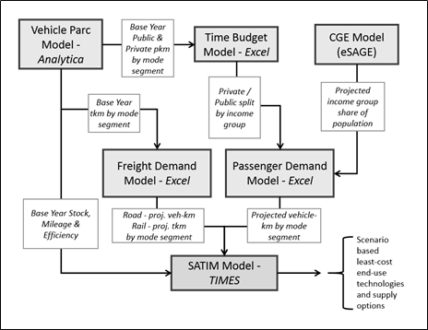

Figure 5: An overview of the SATIM transport sector model (Merven et al 2012).

Demand for vehicle-kilometers of freight in different vehicle classes is linked to sectoral GDP growth, applying load factors and modal shares, which influence fuel efficiency.

Within vehicle classes the model is able to optimise within a constraint on total sales of new vehicle sales. Scrappage factors are applied that reduce the existing vehicle fleet, new vehicles sales are therefore needed to replace older vehicles as they are scrapped as well as to meet new demand.

### Commerce

The commercial sector includes energy used by the wholesale, retail and motor trade services and accommodation (trade); finance, real estate and business services (finance); government; and personal services sub-sectors. Commercial sector demand for energy services is estimated based on an assumed energy intensity of energy services needed as a function of floor area (PJ/m2); the growth in floor area over time; and improvements in energy efficiency as a result of building code regulations. Final energy demand is endogenous in SATIM and is calculated based on the efficiency of technologies supplying energy service needs and their penetration in the sector.

The 2012 USA Commercial Buildings Energy Consumption Survey (2012 CBECS) (EIA, 2016) provides information on electricity usage per square meter by end use for commercial building types. The non-residential building category ‘other non-residential space’ is not represented in the 2012 CBECS survey. A weighted sum of the average electricity intensity for all CBECS building types located in the climate zone most similar to South Africa (i.e. climate zone <4000HDD & <2000CDD)[3] was used to calculate the electricity intensity of energy services per m2. The weights are estimated using StatsSA commercial floor area changes which are applied to 1990 stock estimates from de Villiers (2000). This information is then used to calculate the share of each energy service demand in total electricity usage (per m2). This is applied to electricity usage per m2 data for South Africa to determine South Africa specific electricity usage per m2 for each end use. Energy efficiency improves over time as building codes are updated.

Total commercial floor area was estimated to be around 88million m2 in 2012. This estimate is based on Statistics South Africa’s monthly and annual statistics on the change in floor area by building type (STATSSA, n.d.) and de Villiers (2000) estimate of commercial floor area excluding warehouses in 1990, which was reported to have been 57.9 million m2. Growth in floor area over the model horizon is informed by the relationship between historic growth in floor area and growth in GDP. An analysis of the change in floor area as reported by STATSSA and the growth in real GDP shows that there is a close correlation between the two sets of information, although the change in floor area lags changes in real economic growth by about 2 years. The change in floor area is equivalent to around 70% of the growth in real GDP. This relationship is assumed to hold in the future.

The existing floor area is based on total commercial stock in 2012 with the share of existing floor area decreasing by 1% from 2013. New building floor area therefore increases from 2013 at the rate of commercial floor area growth plus the loss in existing floor area. By 2050, 54% of the total floor area consists of new building stock. It is assumed that energy services in new buildings can be met more efficiently with newer technologies, whilst residual capacity restricts the use of newer technologies in older buildings.

### Industry

The industrial sector consists of several energy intensive sectors, such as the iron and steel sectors as well as smaller producers such as the automotive industry. In SATIM, two methodologies are applied to model industrial energy consumption. The first method (approach one) relies on estimates of energy service needs (lighting, cooling etc), the second method (approach two) utilises an estimate of the energy intensity of industrial technology processes. Approach two is typically applied to sectors where products are more uniform and the energy intensity of production is high. Both approaches are described in more detail below.

**Approach one** is applied to the mining, chemicals, food beverages and tobacco, precious and non-ferrous metals and general manufacturing. In this approach an estimate of the total useful energy service requirement (e.g. Process heat, compressed air, etc), per unit of output or value added, and the efficiency at which energy services are met are exogenously specified and allow the model to endogenously determine final energy consumption for each energy service in the sub-sector. The driver of industrial energy consumption is therefore the demand for useful energy services ***U***. This is demonstrated in Figure 6, where the level of useful energy services needed, in this case process heating, and the efficiency of the boiler, determines the amount of final energy (coal) consumed.

Coal boiler

(% Efficiency)

Process Heat - PJ

Coal - PJ

Figure 7: Technology representation in approach one subsectors in industry – example of a boiler technology

The estimate of base year demand for useful energy services is calculated for each industry subsector ***i****,* technology ***T****,* fuel or commodity ***f,*** and enduse service ***u***(heating, lighting etc.) using the equation below:

Where is the technology efficiency, and the final energy consumed to supply the energy service is calculated according to the share of technologies supplying the energy service

where

is total final consumption of fuel ***f***  by subsector ***i*** (Joules), and

is the % share of final energy supplying end use service ***u***

is the % share of technology ***T*** assumed to supply the enduse service

Assumptions around technology efficiency and energy service levels are drawn from literature and from energy audits and surveys.

**Approach two** is used for the Iron and Steel, Ferroalloys, Non-metallic minerals and pulp and paper sectors. The demand for final energy in these sectors is calculated endogenously based on the energy intensities specific to technology processes and their level of production. For example in Figure 7, the demand for coal and coke by blast furnaces in the production of iron is calculated based on the technology specific energy intensity (GJ/t) of iron production in South African blast furnaces. In order to apply approach two, the share of production by technology type and the energy intensity of production in South Africa must be known or estimated.

Blast Furnace

Intensity:  
Coal GJ/t

Coke GJ/t

Iron - tonnes

Coal - PJ

Coke - PJ

Figure 8: Example of technology representation in approach two subsectors in industry

The production output *O* by product *P* is given as:

where is the activity[4] of a technology ***T***producing product ***P***.

Final energy consumption ***F***of fuel ***f***for an industry is then:

where is the energy intensity for technology ***T***, and represents the fuels.

Figures 8-10 show how existing technology capacity (blue) and new technology additions (green) are explicitly represented in the model. The iron and steel sector, shown in Figure 8, currently produces steel using a range of technologies and fuels. Existing technologies and plants can be retrofit to improve efficiencies. New technologies are also available, allowing the efficiency of production in new plants to be higher. The non-metallic minerals sector (Figure 9) includes the production of cement, glass, lime, and bricks. The pulp and paper (P&P) (Figure 10) sector produces paper, paper products, and dissolving pulp. Steam is a critical component of the energy and process systems for the P&P sector, and biomass residue and production waste are often used as feedstocks for boilers in the pulping process. The Ferroalloys sector (Figure 11) includes the production of Ferro-Chrome, Ferro-Silicon, Ferro-Manganese, and other Manganese alloys in South Africa. The production is ferro-chrome, which is used in the manufacture of stainless steel, dominated ferro-alloy production in South Africa. The majority of energy consumed in the production of ferro-alloys is used in electric arc furnaces which heat a mixture of ore, fluxes and reducing agents (coke and/or coal) for smelting into metal alloy product. Due to the difficulty of accessing information and data for this sector, the ferroalloy industry in SATIM is represented by a single technology – the electric arc furnace (shown in Figure 11). The Aluminium sector is also carved out of the non-ferrous metals sector and is characterised as a single technology consuming electricity to produce Aluminium, with associated process emissions. This is because the Aluminium sector is quite a large consumer of electricity and its activity is not strictly linked to the rest of the non-ferrous metals industry, nor with the rest of the South African economy.

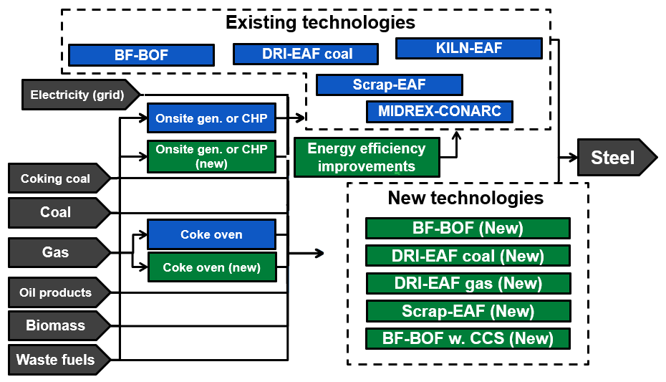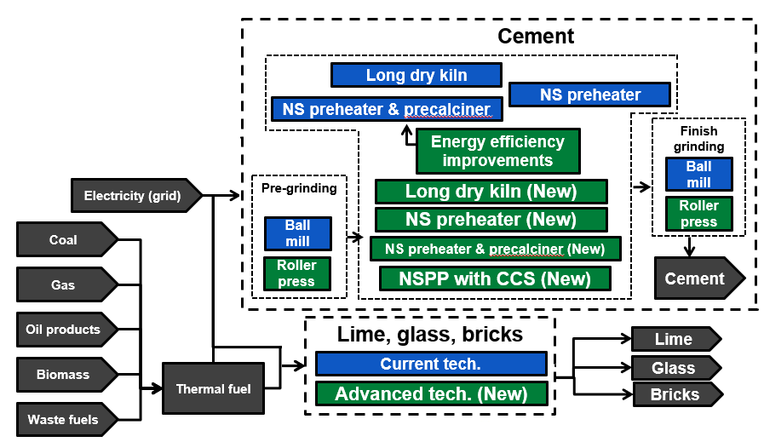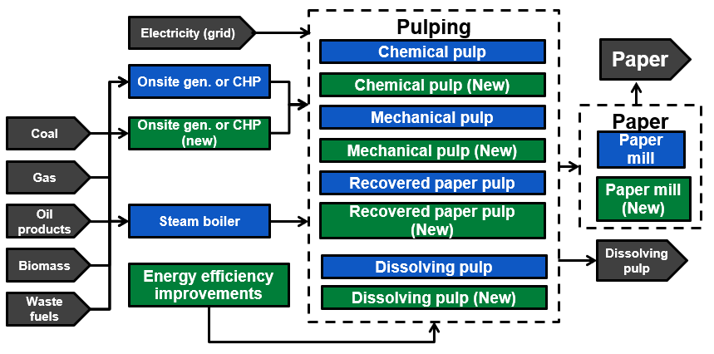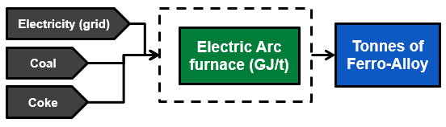

a)

b)

c)

d)

Figure 12: Structure of the a) Iron and Steel b)Non-metallic minerals c) Pulp and Paper industry and d) Ferroalloys representation in SATIM

# Accounting for emissions

Fugitive emissions from extraction and refineries, as well as emissions from combustion, are accounted for in SATIM. Combined they account for 80% of overall GHG emissions in South Africa. Fugitive emissions are accounted for at the source i.e. emissions from mining are accounted for under extraction and refinery emissions are an output of refineries. Both are directly related to output. Emissions from combustion are allocated to sectoral fuel use. They are therefore average emissions that occur as a result of the combustion of coal (of different grades), gas, liquid fuels etc in each sector. Process (IPPU) emissions are accounted for at the process level, except in the case of the 2D: Non-Energy products from fuels and solvent use, and 2F: Product uses as substitutes for ozone depleting substances, which are specified exogenously as a fixed time series. AFOLU and Waste emissions are currently accounted for outside of SATIM.

# Discussion of strengths and limitations of the SATIM modelling approach

A strength of the approach taken in developing SATIM lies in the inclusion of the entire energy system in the model. This allows emissions, including fugitive emissions, and fuel use to be accounted for explicitly for all sectors. This in turn allows for trade-off between sectors when mitigation is required and the targeting of specific sectors in scenarios for policy interventions. The representation of demand for energy services in all sectors, allows efficiency, processes changes and fuel switching on the demand side to complete with changes on the supply side to provide an optimal energy pathway for South Africa to meet future energy service needs under policy or other constraints. For example, it is possible for electricity generation to increase the use of RE, or for the demand sectors to increase their use of RE, or to utilise more efficient technologies to achieve an overarching objective of reducing emissions.

The high level sectoral detail in SATIM matches the energy balances published by the Department of Energy of South Africa. Energy consumption in the base year differs from the DOE energy balances where other published national statistics indicate that adjustments are necessary. This ensures the accuracy of base year demand. However, due to the detailed representation of demand at the energy service level, as well as the delays in publishing the energy balances and national statistics needed to update the model base year, base year updates are irregular. The current base year is 2012with a detailed update for 2017. A feature of TIMES which helps in this regard is that model years can be independent of data years, allowing sector updates to be unconstrained by data availability in all sectors.

Income changes over time play a role in determining the demand for transport, influencing the levels of both tonne and passenger kilometres. In the residential sector income and electricity access play a role in energy service demands, fuel type and efficiency of technologies. Household income growth and electrification therefore need to be accurately reflected in an energy systems model in a way that is consistent with economic growth. In addition, income growth reflected in the transport sector must be consistent with that of the residential sector. This is done in SATIM by linking the model drivers to the output of a CGE model to develop economically consistent scenarios.

Mileage decay and efficiency improvement due to vintaging is explicitly included in the transport sector. Similarly, improvements in the efficiency of building stock over time are included in the commercial sector and in the intensive industries process efficiency of plant can improve with additional investment.

Coal supply to power plants and the plants they supply are represented individually. This allows coal quality and cost to be captured against each power plant individually. It also allows investigation of the optimal path for transformation in the power sector away from coal, based on plant efficiency, cost and other objectives. This is an important component of SATIM as coal is a large portion of TPES, and competition between coal fired plants and RE must be represented as accurately as possible.

An important strength of SATIM is its modularity, allowing easy expansion of sectors and subsectors and energy service representation. The time slice resolution in SATIM can also easily be adjusted according to research needs, and expansion of trade of energy with neighbouring countries can be accommodated, through the utilisation of the regional trade features in TIMES. The flexibility of Timeslice resolution is important as it has implications for RE integration, and model run time. Regional trade is likely to expand in future and having the flexibility to include demand and supply options in neighbouring countries explicitly, at a similar level of detail to SATIM, will allow exploration of optimal energy pathways for the region.

An additional important development in recent years is the soft linking of SATIM to the SAGE Computable General Equilibrium model. The linked model captures economic response to fuel prices which occur for example, as a result of different energy investment paths, and changes to energy service needs in response to GDP growth. Economic consistency in scenarios and demand growth is a concern as growth in all sectors is driven by GDP either directly (e.g. commerce) or indirectly (e.g. residential). The use of a CGE model to develop economically consistent scenarios as well as the linking of SATIM SAGE has allowed the expansion of research to areas such as just transitions and economically and climate optimal development pathways.

As SATIM represents demand in South Africa as a single node the spatial diversity of demand is not captured. Similarly RE and fossil fuel resources are also spatially diverse. Not capturing this diversity has implications for the optimisation of the energy system. For example, power plants that are located far from demand centres do not incur a transmission penalty.

The TIMES approach is normative: optimized from a single agent’s point of view. This is fine for supply, and industry, which normally behave in this way. However, without extensive further disaggregation of the residential demand sector, heterogeneity of preferences is not captured. The cheapest technology will tend to dominate the solution even if there is another product available with slightly higher cost but other non-monetary advantages. The model would therefore benefit from soft linking with more detailed choice models.

Another weakness is the fact that mode choice in transport is exogenous. To accurately reflect modal shift in the transport sector within SATIM would require further disaggregation to reflect transport demand in the larger cities of South Africa. Each city has its own peculiarities, for example whether rail transport is available, which would have to be captured, in order for modal switch to be endogenized.

# Conclusions

This paper presents an overview of SATIM, a full sector, technology rich, optimisation model of the South Africa Energy system. SATIM is unique in its representation as presented in this paper. Important features in SATIM are that it has been developed in a way that allows changes to its modular structure and temporal resolution allowing shifts in technology, sector expansion, or increased data resolution to be incorporated as the need arises. These features have allowed SATIM to be adapted to be utilised to inform a wide range of critical policy questions in South Africa, including climate change responses.

Presenting SATIM in an open manner in this paper has three advantages: firstly it allows critique of the modelling system and assumptions; secondly it allows others facing similar challenges related to characterising a developing country energy system and data scarcity to review the approach taken to overcome these issues in the development and maintenance of an energy systems model and; thirdly as SATIM has already been used, and will continue to be used, to deliver insights into policy questions it is imperative that the assumptions behind the model are in the public domain and can be interrogated.

In order to ensure SATIM’s relevance the base year and model structure have been updated as often as possible. In order for SATIM to remain relevant the update cycle needs to continue.. SATIM is now stored an open access version-control system which can be accessed here: ….. Flexible spatial disaggregation into provinces/cities would also be a great enhancement.

# Acknowledgments

This paper is written with the support of South African National Energy Development Institute, who have also contributed to the development of SATIM, the calibration of base year data, and the linking of SATIM to SAGE.

# References

Ahjum, F., Merven, B., Stone, A., & Caetano, T. (2018). Road transport vehicles in South Africa towards 2050 : Factors influencing technology choice and implications for fuel supply. *Journal of Energy in Southern Africa*, *29*(3), 33–50.

Altieri, K. E., Trollip, H., Caetano, T., Hughes, A., Merven, B., & Winkler, H. (2016). Achieving development and mitigation objectives through a decarbonization development pathway in South Africa. *Climate Policy*, *16*(sup1), S78–S91. https://doi.org/10.1080/14693062.2016.1150250

Alton, T., Arndt, C., Davies, R., Hartley, F., Markelov, K., Thurlow, J., Ubogo, D., (2014): Introducing Carbon Taxes in South Africa. *Applied Energy*, 116 344–354. Web.

Blignaut, James et al. (2016) “The Economic and Environmental Effects of a Carbon Tax in South Africa: A Dynamic CGE Modelling Approach.” *South African Journal of Economic and Management Sciences 19.5 .*

Bohlmann, H.R. et al. “Regional Employment and Economic Growth Effects of South Africa’s Transition to Low-Carbon Energy Supply Mix.” *Energy Policy*, 128 (2019): 830–837. Web.

Burton, J., Caetano, T., & Mccall, B. (2018). *Coal Transitions in South Africa: Understanding the implications of a 2°C-compatible coal phase-out for South Africa*. Retrieved from https://coaltransitions.files.wordpress.com/2018/09/coaltransitions_finalreport_south-africa_2018.pdf

De Carolis, J. F., Hunter, K., & Sreepathi, S. (2012). The case for repeatable analysis with energy economy optimization models. *Energy Economics*, *34*(6), 1845–1853. https://doi.org/10.1016/j.eneco.2012.07.004

de Villiers, M. 2000. *Greenhouse gas baseline and mitigation options for the commercial sector.* Report number EDRC/00/R5, Energy and Development Research Centre, University of Cape Town: Cape Town, South Africa.

DESA, U., 2019. World Population Prospects 2019. United Nations. Department of Economic and Social Affairs. *World Population Prospects 2019*.

DOE. (2013). *A survey of energy-related behaviour and perceptions in South Africa 2013*. Pretoria, South Africa. Retrieved from http://www.energy.gov.za/files/media/Pub/Survey of Energy related behaviour and perception in SA - Residential Sector - 2012.pdf

DOE. (2018). *Integrated Resource Plan (draft)*. Pretoria, South Africa.

Energy Information Administration (EIA). 2016. *2012 Commercial Buildings Energy Consumption Survey Data*. Available: <http://www.eia.gov/emeu/cbecs> [May 2019].

Hiremath, R. B., Shikha, S., & Ravindranath, N. H. (2007). Decentralized energy planning ; modeling and application — a review. *Renewable and Sustainable Energy Reviews*, *11*, 729–752. https://doi.org/10.1016/j.rser.2005.07.005

Jebaraj, S., & Iniyan, S. (2006). A review of energy models. *Renewable and Sustainable Energy Reviews*, *10*, 281–311. https://doi.org/10.1016/j.rser.2004.09.004

Laha, P., & Chakraborty, B. (2017). Energy model – A tool for preventing energy dysfunction. *Renewable and Sustainable Energy Reviews*, *73*(April 2016), 95–114. https://doi.org/10.1016/j.rser.2017.01.106

Li, F. G. N., Bataille, C., Pye, S., & Sullivan, A. O. (2019). Prospects for energy economy modelling with big data : Hype , eliminating blind spots , or revolutionising the state of the art ? *Applied Energy*, *239*(February), 991–1002. https://doi.org/10.1016/j.apenergy.2019.02.002

Lopion, P., Markewitz, P., Robinius, M., & Stolten, D. (2018). A review of current challenges and trends in energy systems modeling. *Renewable and Sustainable Energy Reviews*, *96*(July), 156–166. https://doi.org/10.1016/j.rser.2018.07.045

Mccall, B., Burton, J., Marquard, A., Hartley, F., Ahjum, F., Ireland, G., & Merven, B. (2019). *Least-cost integrated resource planning and cost- optimal climate change mitigation policy : Alternatives for the South African electricity system*. Retrieved from http://www.erc.uct.ac.za/sites/default/files/image_tool/images/119/Papers-2019/Alt IRP final 07022019_2.pdf

Merven, B., Stone, A., Hughes, A., & Cohen, B. (2012). Quantifying the energy needs of the transport sector for South Africa: A bottom-up model.

Merven, B., Durbach, I., & McCall, B. (2016). *Obtaining long-term forecasts of the key drivers of greenhouse gas emissions in South Africa.*

Merven, B., Ireland, G., Hartley, F., Arndt, C., Hughes, A., Ahjum, F., Mccall, B., Caetano, T., (2018). *Quantifying the macro- and socio-economic benefits of a transition to renewable energy in South Africa*, SA-TIED working paper.

National Planning Commission (NPC). (2018). *NPC Economy Series: Energy*.

Stone, A., Merven, B., Maseela, T., & Moonsamy, R. (2018). Providing a foundation for road transport energy demand analysis: A vehicle pare model for South Africa. Journal of Energy in Southern Africa, 29(2), 29-42.

Neshat, N., Amin-Naseri, M. R., & Danesh, F. (2014). Energy models : Methods and characteristics. *Journal of Energy in Southern Africa*, *25*(4), 101–111.

World Bank Group. (2017). *Modeling the Water-Energy Nexus: How do Water Constraints Affect Energy Planning in South Africa*. Washington DC. Retrieved from https://openknowledge.worldbank.org/handle/10986/26255 License: CC BY 3.0 IGO.

1.
2. For more information see (Ahjum, Merven, Stone, & Caetano, 2018)
3. HDD and CDD refer to heating and cooling degree days and indicate the energy demand needed to heat and cool a building, respectively, to get to the base temperature 65°F (18°C).
4. The activity of a technology is bound by limits by the user, but is determined in future years by the optimisation program